LAB Logbook

WEEK 4

Model Summary

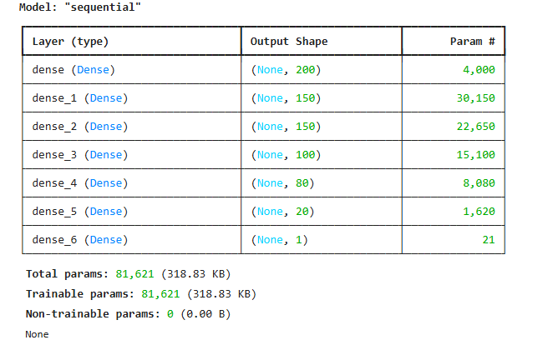

Graph

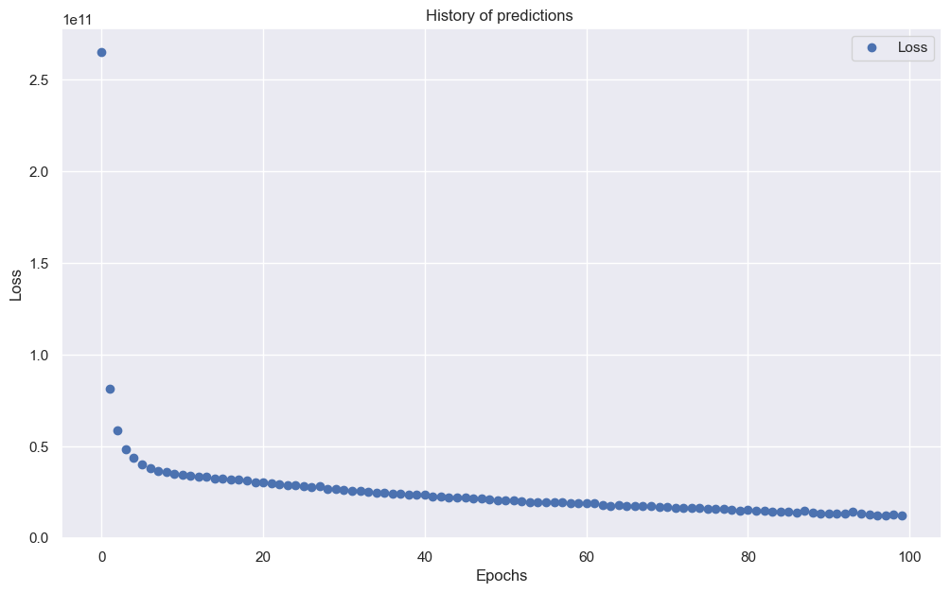

**Prediction Results:**

absolute prediction error = 19332.0 $

relative prediction error = 8.71203244704822 %